(Sample TSD Application)

TSD

For Internal Use Only
Trademark Acknowledgments
Any and all products or brand names mentioned in this document are trade names, service marks, trademarks or registered trademarks of their respective owners.
This document is the confidential and proprietary product of abc Corp. Any unauthorized use, reproduction, or transfer of this manual is strictly prohibited. All rights reserved.

Version | Author | Date | Updates
0.1 | XYZ | 04/08/09 | Initial Draft

File location: TBD
Table of Contents
1 Technical Framework 1
1.1 Technical Environment Specifications 1
1.1.1 Development Environment 1
1.1.2 Test and Staging Environment 1
1.1.3 Production Environment 2
1.2 Technical Constraints 2
2 Existing System Structure 3
2.1 Proposed Changes: 3
2.2 Document Scope 5
3 System Design 6
3.1 Design Illustration 6
3.1.1 Software Architecture 6
3.1.1.1 Inbound Real Time Messaging from GEG to OneTIS 6
3.2 External Interface Design 7
3.3 Inbound Messaging Process 7
3.3.1 Configuring Sonic MQ for Inbound Message: 9
3.3.2 Configuring the Listener:- 9
3.3.3 Message Listener: 11
3.3.3.1 Connection 11
3.3.3.2 Initialize logging 11
3.3.3.3 Create Consumers & Handler: 11
3.3.3.4 Registering the process: 11
3.3.3.5 On message arrival: 11
3.3.3.6 Parsing/Extracting the Message: 12
3.3.3.7 Validation & Storing to Database: 12
3.3.3.8 Listener Status: 12
3.4 Functional Unit Design 13
3.4.1 Shell Scripts 13
3.4.2 Message Processing (Listeners & Dom Processor) 14
3.5 User Pref maintenance 15
3.6 Exception Handling 17
3.7 Data Design (Rshsecurity & RshCompany ) 17
3.7.1 Inbound message XML Schema & Grid Layout 17
3.7.2 Tradesys DB Schema 20
3.8 XML Attributes To DB Mapping 20
4 Test Specifications 21
4.1 Test Framework 21
4.2 System Test Process 21
4.3 Subsystem Test Specifications 22
4.4 Testing Approach 22
5 Implementation Processing Requirements 23
6 Technology Concepts 25
Appendix A – System Acceptance Test Flowcharts 26
Approval Log 27

The level of detail and formality of each section is dependent upon the project’s unique circumstances.
If any section is not applicable, the section header will remain in place and text content will indicate that the section is not applicable.
All timeframes referenced in this document are based upon documented and approved requirements in earlier phases of the project. The confidence level of these estimates is projected to be approximately ninety percent (90%).
This project will be developed and managed in accordance with Summit D Methodology.

Technical Framework

Technical Environment Specifications

Development Environment
The OneTIS development environment resides on the following:
- An IBM AIX machine for Progress AppServer procedures development and unit testing
- The development workstations for Progress 4GL, XmlSPY and SonicMQ for development
The majority of the development tasks will be completed on the developer workstations.
The following table summarizes all of the hardware and software needed for the development environment:
Server / Workstation | Hardware Specification | Software Installed
IBM AIX machine (IBM H70 AIX 4.3.3.0 – SACRS45) for Progress 4GL development | Existing | Existing  Progress AppServer 9.1D  Progress RDBMS
XML Schema Editor | Existing | Windows 2000  Progress 4GL AppBuilder 9.1D  XmlSpy
Sun Solaris machine (SUN SunOS 5.7 – SACSUN74) for SonicMQ & IBM MQ | Existing | Progress SoncMQ  SonicMQ/IBM MQ Bridge  IBM MQ

Test and Staging Environment
The main purpose of the test/staging environment is to test the application code in an environment that is similar to the production environment. The test environment would use the same infrastructure as the development environment, but the two environments will be logically separated.
Server / Workstation | Hardware Specification | Software Installed
IBM AIX machine (IBM H70 AIX 4.3.3.0 – SACRS45) for Progress 4GL testing | Existing | AIX  Progress AppServer 9.1D  Progress RDBMS
Build & Test Workstation for Progress 4GL and Progress 4GL components | Existing | Windows 2000  Progress 4GL AppBuilder
Sun Solaris machine (SUN SunOS 5.7 – SACSUN74) for SonicMQ & IBM MQ | Existing | Progress SoncMQ  SonicMQ/IBM MQ Bridge  IBM MQ

Production Environment
The production environment would host the production instance of the TIS application. The Progress part of the application would use the same environment as the current TIS application (primary + failover and disaster recovery).
In addition the production environment for the GUI applications related Web Client components would reside on the following:
- Users workstations with a minimum configuration of 128 Mb RAM, 20 GB HDD, Pentium or greater
Server / Workstation | Hardware Specification | Software Installed
IBM AIX machine (BM P680 AIX 4.3.3.0 A & B servers with HACMP -SACRS38/40) for OneTIS application | Existing | Existing  Progress AppServer 9.1D  Progress RDBMS
User Workstation | Existing | Windows 2000  Progress 4GL AppBuilder
Sun Solaris machine (SUN SunOS 5.7 - SACSUN15) for messaging - SonicMQ & IBM MQ | Existing | Progress SoncMQ  SonicMQ/IBM MQ Bridge  IBM MQ

Technical Constraints
NA

Existing System Structure
- OneTIS (Trading Information System) is built on Progress 9.1D RDBMS. It encompasses the Front Office and Back-Office processes including Trading, Settlements, Research, Data Maintenance, Portfolio Management, and other functions. The application runs on S7A IBM server with Fail over capability. Each of the two-mirrored machines run AIX 4.3.3, with 12 CPU’s and 8 GB ram. A disaster-recovery machine sits in Rancho Cordova and is a smaller version of the production machines. It is synchronized on a regular basis.
- The current GLE Research subsystem consists of the following components: Research Database, OneTIS Research Menu, research on-line and batch reports, research data entry and on-line query screens, and research data extracts.

Proposed Changes:
- The current GLE Research subsystem is going to be removed from the OneTIS application.
- It is proposed to be developed as a separate application “GEG” with .Net interface and Oracle as backend.
- Since the GLE Research is going out of OneTis, The programs which uses research data in other departments in Onetis will get affected.
- New tables were created in tradesys In order to minimize the impact of the removal and to make the research reference programs in other departments to work as it was working fine when research database was there in OneTIS.
- Two New tables rshsecurity and rshcompany is created in tradesys which is a replication of the old GLE research tables.
- The GLE Research table driss is replaced by rshsecurity and the table drcmp is replaced by the rshcompany.(Schema attached)
- There will be a One time data population(data dump) done to the newly created rshcompany and rshsecurity tables from the old driss and drcmp tables before the research database is removed.
- Inorderto keep the two research tables in OneTIS synchronized with the tables in the new GEG application, Realtime Inbound Xml messaging is enabled from GEG to OneTis.
- This Xml message which contains the research security and research company data is sent by the GEG application via MQSI and Sonic MQ.
- There will be a separate queue configured in the sonicMQ for the Inbound messages coming from GEG.
- Listeners will be configured in OneTIS Which listens to the inbound messaging queue.
- Once the message hits the queue, the listener will pickup the message and based on the root name, it calls the appropriate Handler program which parses the message and extracts the data.
- This extracted data is populated and stored in a temp-table
- This temp-table objects are validated against a custom validation check.
- If the validation is successful then the data is committed to the database and the xml message is written to a file for backup.
- If the validation fails then the error is logged and the xml message is written to a file.
A Brief outlook of the architecture involved in Inbound messaging is as follows:
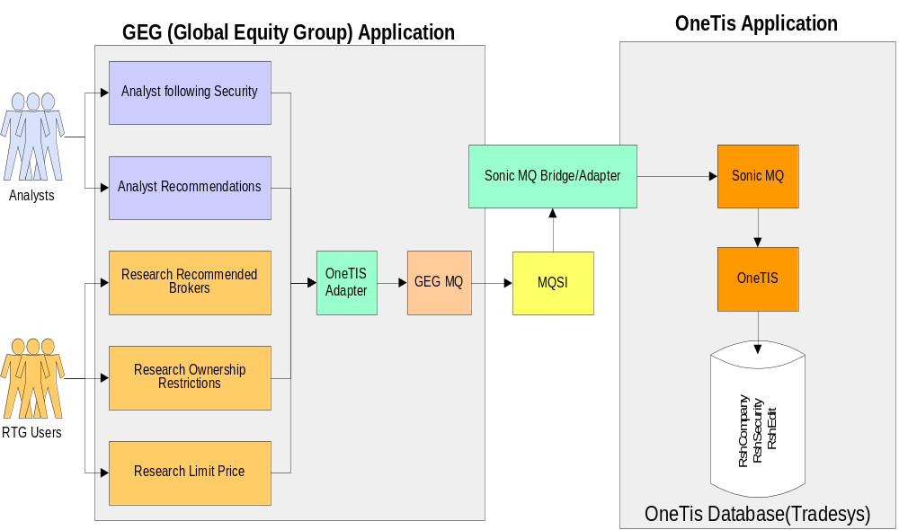

Document Scope
This Document covers:
- The process involved in inbound XML messaging on OneTIS side.
- Technical Program Design of the Modules involved.
- The Schema for the Inbound xml message
- The Xml Attributes to the field-name mapping of the new tables.
- Database Physical schema(ER diagram).
- Exception Handling in the process.(TBD)
- Test Specification.(TBD)
- Installation plans.(TBD)
- Implementation processing requirements(TBD)

System Design

Design Illustration

Software Architecture

Inbound Real Time Messaging from GEG to OneTIS
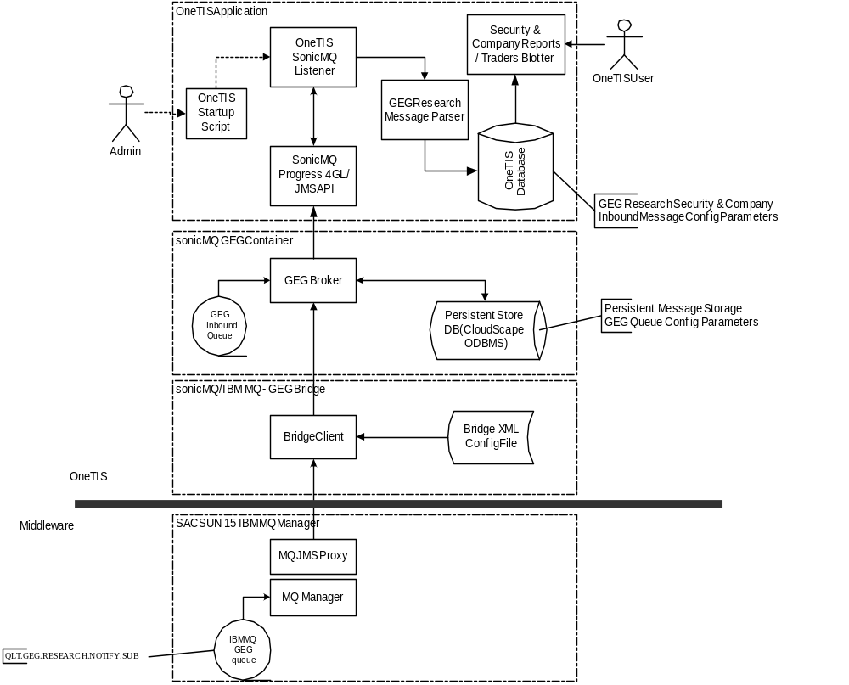

External Interface Design

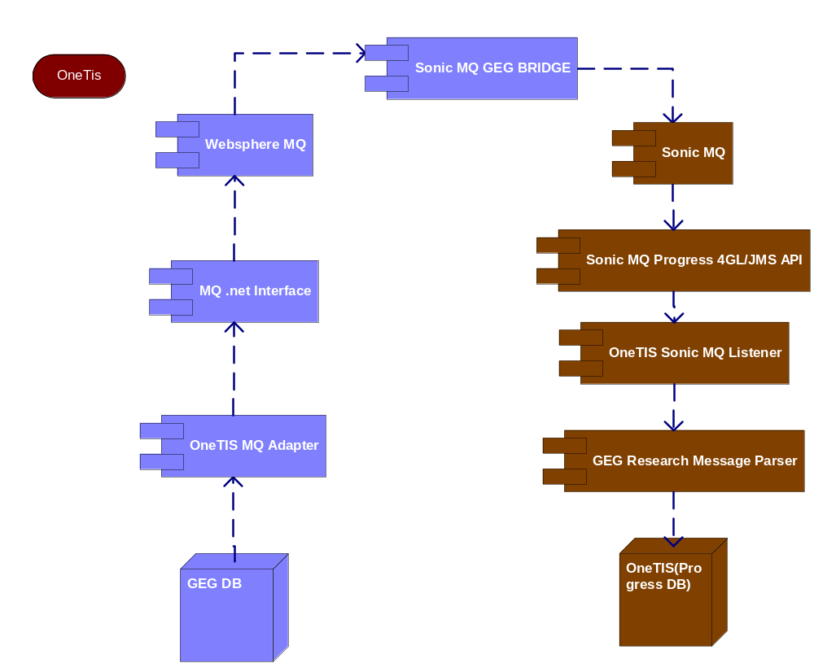

Inbound Messaging Process
- Configuring the inbound SonicMQ queue
- Configuring the Listener
- Activating the Listener
- Listening to the Incoming Messages
- Calling the respective Program depending on the message type by removing the soap envelope
- Parsing the XML message using DOM and extracting the data from the message.
- Persist the validated data to the new tables.

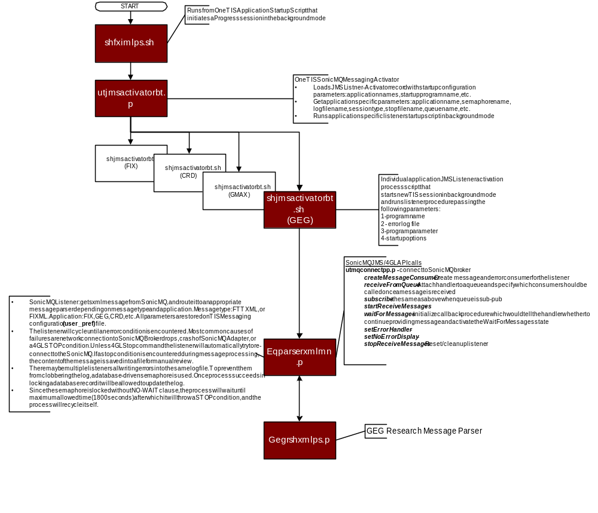

Configuring Sonic MQ for Inbound Message:
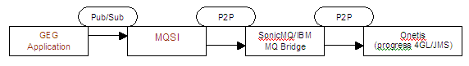

- SonicMQ Communicates with MQSI thru IBM MQ/sonicMQ bridge.
- In sonicMQ each application is configured to have its own container and respective number of queues as required by that application.
- The configuration for the Inbound queue, will be provided in the “Config.xml” file in the SonicMQ.(To be attached in the document)
- Other application specific parameter configured in that includes Application Name, Debug level, Log file, log directory, session type, save xml, stop file, XML save directory etc..
- Once the inbound queue is configured, it can be started from the admin console of sonicMQ.
- The Listener to be configured for that specific application Listens to this queue.
- In order to stop the Queue, a Stop file for that queue can be triggered to shutdown the queue.

Configuring the Listener:-
shfixmlps.sh:
- A generic shell script “shfixmlps.sh” starts a separate OneTIS Session in the background which is called from the OneTIS startup Script in the global start of listener.
- This script takes three parameters:
1. Operation 2. queue(valid queue name) 3. queue number.
- For Parameter “Operation”, it takes either of three values as ‘start’ / ‘stop’ / ‘query’. If there is no input values supplied to the parameter “operation”, then it exits the process and log the error to a log file “reports/utjmsactivatorbt.err”.
- This script passes the input parameters to the module util/utjmsactivatorbt.r and runs the module which activates the OneTis – sonicMQ messaging process.
utjmsactivatorbt.r:
- The module utjmsactivatorbt.r, takes the input parameters passed by the shell script and runs the utility program ‘util/utenvironmentfd.r’ which finds the environment the process is running as dev/UT/Live.
- It then runs the module ‘util/utprofileclpp.r’ which retrieves the configuration(program to be called with its parameters) relating to the queue name from the user_pref table for that specific environment.
- The user_pref table is like a property file, which is Used for retrieving user preferences & configuration information for various messaging modules.
- It then assigns the application specific parameters like program name, errorLogFile, queue name, startOptions to a generic shell script shjmsactivatorbt.sh.
shjmsactivatorbt.sh:
- It takes four input Parameters
1. program name 2. error log 3. program param 4. Options(startup). The first two input parameters are mandatory.
- This runs the application specific listener startup program “eqparsexmlmn.r” in the background mode.

Message Listener:
Eqparsexmlmn does the following:

Connection
On initializing it connects to sonic MQ.
RUN util/utmqconnectpp.r PERSISTENT SET mqHandle.

Initialize logging
Initialize logger – There may be multiple listeners all writing errors into the same log file. To prevent them from clobbering the log, a database-driven semaphore is used. Once process succeeds in locking a database record it will be allowed to update the log. When semaphore is blank, locking will not be performed.

Create Consumers & Handler:
It creates message and error consumer for the listener. It attach message Handler to a PTP queue and specify which consumer to be called based on message received. It also deletes message consumers to free up resources.

Registering the process:
It register a process with valid process id. If no id exist then it assigns a process id to it.

On message arrival:
It checks for the type of message by checking its root name. Since for GEG Inbound message we are going to use soap enveloped message, This soap envelope has to be taken off before passing it to the procedure.
If the root name is null then it writes to log as “Incoming file not in XML format.”. deletes the object and exits the process.
If the root name equals "AdminShutDown" then it writes to log as “"Listener received shutdown request ... initiating shutdown ...".”.
If the root name equals GEG.Research.Notification, then it calls our specific parsing program “gegrshxmlps”.

Parsing/Extracting the Message:
The module gegrshxmlps is specific parsing program for the geg.research.notification xml message from GEG.
It parses the xml by using Document Object Model parser.
It includes Two temp-table for rshsecurity and rshcompany.
It iterates to each node of the xml DOM and extracts the data and populates the temp-table.

Validation & Persisting to Database:
After completing the temp-table population, the temp-table objects are validated against custom validation check.
If the validation is successful then it persist the data in the temp-table to the database and writes the xml document to the local file system for backup and updates the log.
If there is invalid datas in the message and the validation fails, then it writes the xml document to the local file system for backup and update the log with the error.

Listener Status:
Once done with the parsing, it cleans up the memory handled by the Document object model and goes in to wait state in order pickup messages as it comes.

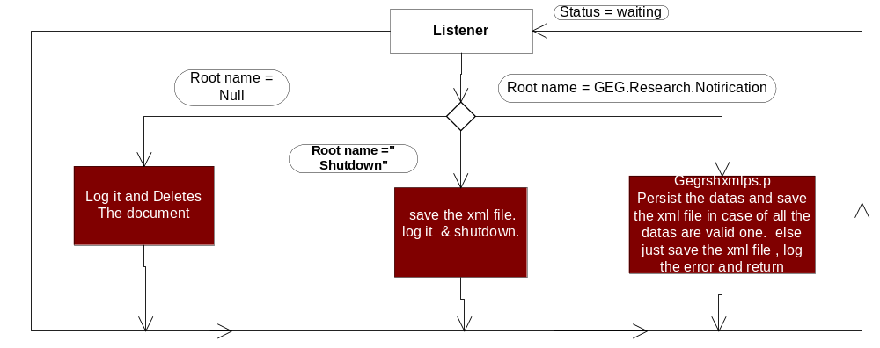

Listener Monitor: (Right now there is no monitor used.)
Another script shfixlismon.sh Monitors FIX queue listeners to ensure the correct number of listeners are running. The number of required queue listeners per queue are stored in '.lck' files, one per queue. For example '/tmp/fix/gegqueue.lck will be created by shfixmlps.sh on a global start of the gegqueue listeners and will store the number of listeners started for that queue. If this monitors detects that there are less listeners than the expected number, it will start the required number of listeners. Shfixlismon calls the Jms API specific calls to get these parameters. It runs the program eqparsexmlmn.r

Functional Unit Design

Shell Scripts
Module Name | Description
Shfixmlps.sh | JMS Listener activator  Access:  Runs in the background, starting separate OneTis Session from the Shell scripts.  Called Modules:  util/utjmsactivatorbt.r - Activates Jms listening process  reports/utjmsactivatorbt.err - Used for error logging  Parameters:  OPERATION  QUEUE  QUEUENUMBER  Description:  The parameters are to be passed from the console. It checks for the parameters passed. If the param value is not valid then it writes to the error log and exits. For our Inbound messaging a Queue name should be configured like “gegqueue”.
Shjmsactivatorbt.sh | JMS Listener activator process. It is launched from the activator's 4GL program.  Access:  Runs in the background. The Module utjmsactivatorbt calls this script.  Description  This script runs the application specific listener activator module eqparsexmlmn by passing the application specific params from the user pref table. No Changes Needed for the Exisiting script

Message Processing (Listeners & Dom Processor)
Module Name | Description
Utjmsactivatorbt.p | Activates JMS Listener Processes  Access:  The script shfixmlps.sh calls this module.  Procedures:  P_processRequest  Functions:  fn-GetValidListenerCount  fn-Init  fn-ProcessEntries  fn-RemoveEntry
Eqparsexmlmn.p | Get xml message from SonicMQ, and route it to appropriate message parser depending on message type. Message type can be FTTXML, or FIXML  Procedures:  p_addPID – It adds a process id to a process and locks it in the table. If there is no PID then it assings one as follows.  ASSIGN alf.admtype = "PID:" + v-mqEnv + ":" + v-queueParam  p_createConsumers – It Creates message consumer for the listener and attach message consumer to a PTP queue  p_deleteConsumers - Delete message consumers to free up resources.  p_ErrorHandler – Handles the error caused by JMS at sonic MQ level  p_exitCleanup - Cleanup files on exit if necessary  p_LogError -  p_removePID – TBD  p_setConfiguration - Configure listener parameters by taking the input params from the user pref table for a specific queue  p_writeConfig - Dumps out configuration information for the listener  p_XMLMessageHandler – Receives an XML message once it hits the queue.  Functions:  fn-GetDebugLevel  fn-GetLogfile  fn-GetPause  fn-Init  fn-InitLogger  fn-InitMQ  fn-inWait  fn-RemoveEntry  fn-reset  fn-SetTimestamp  fn-WriteMessageToFile  fn-WriteRawMessageToFile  Jms api based calls:  SonicMQ JMS/4GL API calls  utmqconnectpp.p - connect to SonicMQ broker  createMessageConsumer - Create message and error consumer for the listener  receiveFromQueue - Attach handler to a queue and specify which consumer should be called once a message is received  subscribe - the same as above when queue is sub-pub  startReceiveMessages -  waitForMessages - initialize callback procedure which would tell the handler whether to continue providing message and activate the Wait For Messages state  stopReceiveMessages - Reset/cleanup listener
Gegrshxmlps.p | Specific Module for Parsing, Validating & persisting the XML data to the database  Access:  Runs In the background. The Module eqparsexmlmn calls it when it receives xml message from GEG with root name “GEG.Research.Notification”  Description:  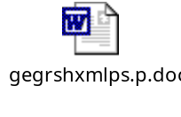

User Pref maintenance
UID | AppType | Pref_Name | Pref_Value | Details
GEG | Archive | ArchiveDir | /Save/geg/ | Archive Folder – XML Files
GEG | Archive | CutoffDays | 10 | Days to Keep before archival
GEG | Archive | Debug | FALSE | Logger Mode
GEG | Archive | DirMode | 770 | Unix Specific
GEG | Archive | FileMode | 440 | Unix Specific
GEG | Archive | GZIP | Gzip –9 | Unix Specific
GEG | Archive | LogFileBase | ../data/geg/log/msgarchivebt | Base Log File
GEG | Archive | Readonly | FALSE | Unix Specific
GEG | Archive | ReadOnlyCommand | cp –p | Unix Specific
GEG | Archive | SweepBaseDir | ../data/geg/ | Base GEG folder – All GEG related documents (logs etc) to be stored here
GEG | Archive | SweepDirList | Status,inbound,outbound,log | Folders to Cleanup
GEG | Archive | TMPDir | /tmp/ | Temporary folder
GEG | Archive | WriteCommand | mv –f | Unix Specific
GEG | JMSSender | ApplicationName | GEG | Application Name
GEG | JMSSender | CheckDependency | FALSE | Switch “On” if one message
GEG | JMSSender | DebugLevel | DEBUG | Setup Logging level
GEG | JMSSender | ErrorLogFile | GEG-mcp-&2.err | Error Log file
GEG | JMSSender | LogDir | ../data/geg/log | Folder to store log file
GEG | JMSSender | LogFileTemplate | GEG-&1-&2.log | Basic Log Template
GEG | JMSSender | InboundXMLDir |  | Inbound Messages – XML store folder
GEG | JMSSender | MessageTypes |  | Can be used for setting up multiple message types – In our case its only “GEG”
GEG | JMSSender | PauseInterval | 5 | Pause between two message send batch processes
GEG | JMSSender | QueryAppname | GEG | Application identifier for Generic Query
JMSListener | GEGQueue | ApplicationName | GEG | Application Name
JMSListener | GEGQueue | DebugLevel | DEBUG | Setup logging level
JMSListener | GEGQueue | ErrorLogFile | gegqueue-&2.err | Error Log file
JMSListener | GEGQueue | LogDir | ../data/geg/log | Folder to store log file
JMSListener | GEGQueue | LogFileTemplate | gegqueue-&1-&2.log | Basic Log Template
JMSListener | GEGQueue | XMLSaveDir | ../data/geg/inbound | Messages – XML store folder
JMSListener | GEGQueue | SessionType | Ptp | PTP or Pub/Sub
JMSListener | GEGQueue | StopFile | ../data/geg/listener.stop | Stop File –used for shutting down the process
JMSListener | GEGQueue | SaveXML | TRUE | Save / no Save XML Message files
JMSListener | GEGQueue | SemaphoreName | GEGQUEUE | Semaphore Name for Queue
GEGMQDev | JMSConnection | AdapterHost | Localhost | SonicMQ Adapter Host
GEGMQDev | JMSConnection | AdapterName | Fixmq | SonicMQ Adapter Host Name
GEGMQDev | JMSConnection | AdapterPort | 6164 | SonicMQ Adapter Port no.
GEGMQDev | JMSConnection | DefaultDelivery | PERSISTENT | Is the Queue Persistent?
GEGMQDev | JMSConnection | DefaultTTL | 3600000 | Time To Live
GEGMQDev | JMSConnection | PingInterval | 30 | Ping Interval to check for connectivity to SonicMQ
GEGMQDev | JMSConnection | SonicBrokerURL | Fixdev:2510 | SonicMQ Broker Host & Port no.
GEGMQDev | GEGQueue | IBQueue | QD.TIS.GEG.IBQueue | Inbound Queue Name
GEGMQUT | JMSConnection | AdapterHost | Localhost | SonicMQ Adapter Host
GEGMQUT | JMSConnection | AdapterName | Fixmq | SonicMQ Adapter Host Name
GEGMQUT | JMSConnection | AdapterPort | 6164 | SonicMQ Adapter Port no.
GEGMQUT | JMSConnection | DefaultDelivery | PERSISTENT | Is the Queue Persistent?
GEGMQUT | JMSConnection | DefaultTTL | 3600000 | Time To Live
GEGMQUT | JMSConnection | PingInterval | 30 | Ping Interval to check for connectivity to SonicMQ
GEGMQUT | JMSConnection | SonicBrokerURL | Fixdev:2510 | SonicMQ Broker Host & Port no.
GEGMQUT | GEGQueue | IBQueue | QT.TIS.GEG.IBQueue | Inbound Queue Name
GEGMQLive | JMSConnection | AdapterHost | Localhost | SonicMQ Adapter Host
GEGMQLIVE | JMSConnection | AdapterName | Fixmq | SonicMQ Adapter Host Name
GEGMQLIVE | JMSConnection | AdapterPort | 6164 | SonicMQ Adapter Port no.
GEGMQLIVE | JMSConnection | DefaultDelivery | PERSISTENT | Is the Queue Persistent?
GEGMQLIVE | JMSConnection | DefaultTTL | 3600000 | Time To Live
GEGMQLIVE | JMSConnection | PingInterval | 30 | Ping Interval to check for connectivity to SonicMQ
GEGMQLIVE | JMSConnection | SonicBrokerURL | Fixprod:2510 | SonicMQ Broker Host & Port no.
GEGMQLive | GEGQueue | IBQueue | QP.TIS.GEG.IBQueue | Inbound Queue Name

Exception Handling
Following are the possible exceptions identified during the real-time communication between GEG To OneTis.
ID | Context | Exception Location (Owner) | Exception Description
GO-EXC1 | GEG To OneTis | OneTis & GEG | Message is sent from GEG and has not reached OneTis.
GO-EXC2 | GEG To OneTis | OneTis & GEG | Message is received at OneTis from GEG, but the data is bad/invalid.
GO-EXC3 | GEG To OneTis | OneTis | Message is received at OneTis from GEG, but before it is saved to OneTis, the system crashed
GO-EXC4 | MQ Connection | OneTis | The connection of Sonic MQ Listener Drops.

Following sections explain the details about how each of the exception would be handled in OneTIS.
TBD (in TSD 1.4 they have suggested about reconciliation process & ETL as options – Discuss)

Data Design (Rshsecurity & RshCompany )

Inbound message XML Schema & Grid Layout

Schema of Inbound Message | 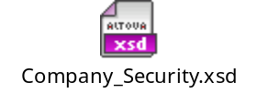
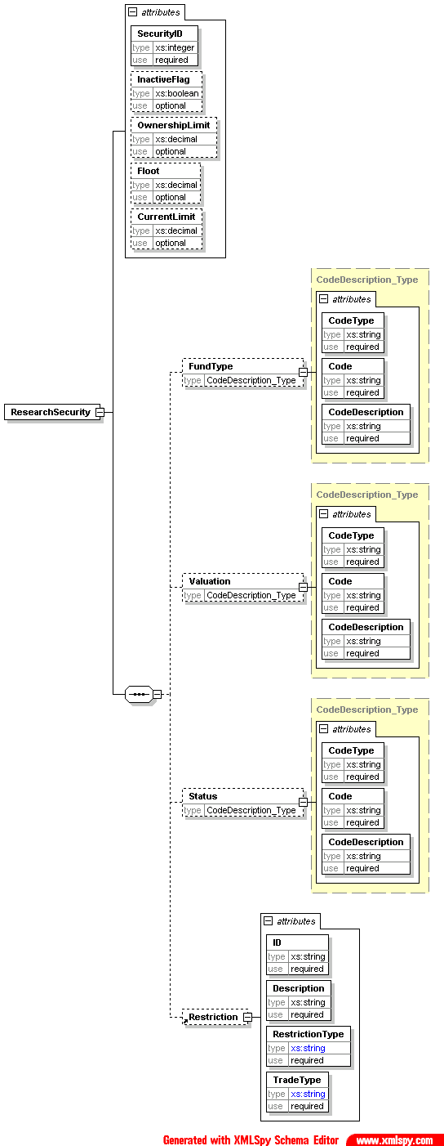
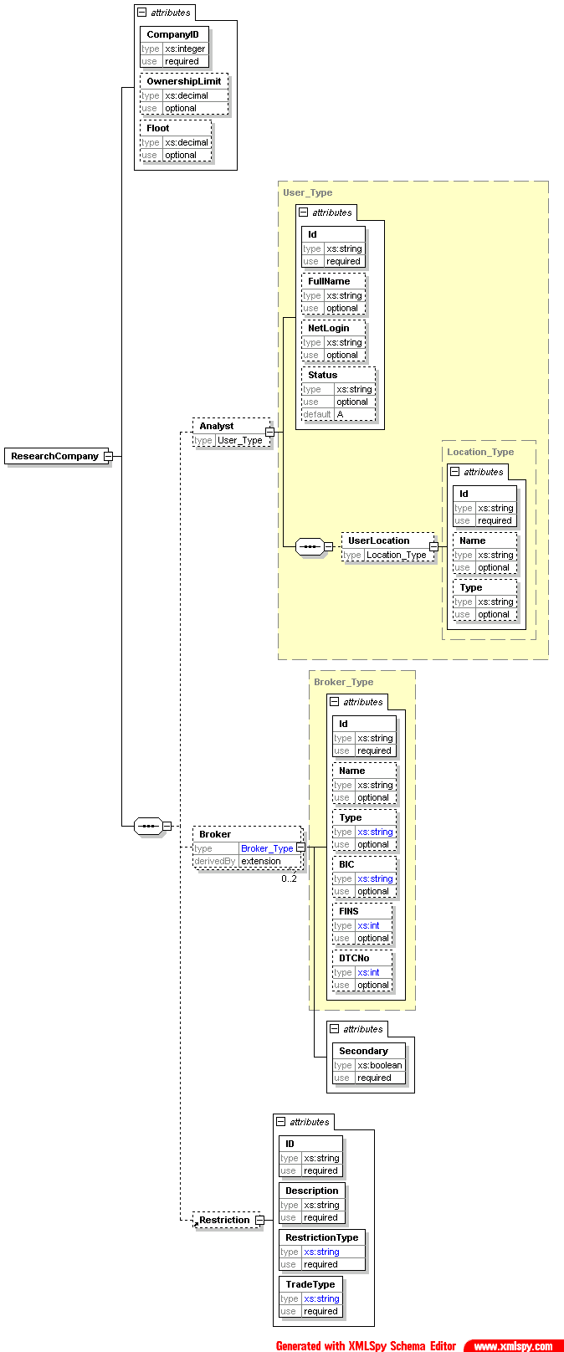

Tradesys DB Schema

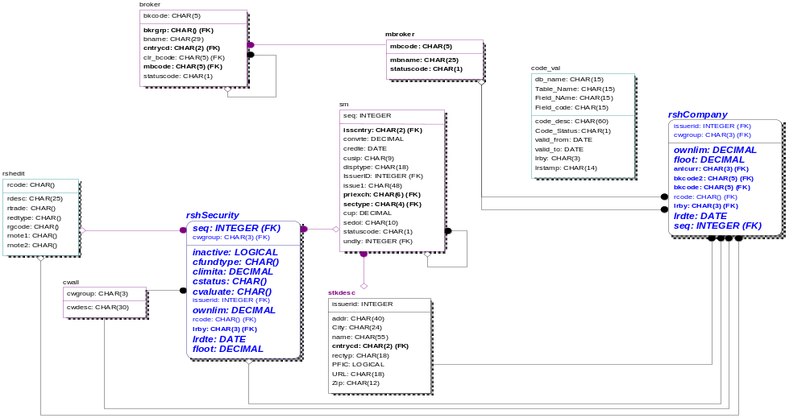

XML Attributes To DB Mapping

- Xml attributes to DB mapping | 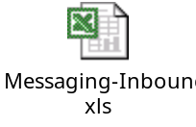

Test Specifications

Test Framework
Testing will be conducted in a phased manner. The phases include unit testing, system testing, QA testing, and user acceptance testing. To accommodate the phased approach, multiple test environments will need to be made available. The division between development, test and production environments needs to be maintained.
- Unit Testing: Unit testing will be conducted using the current TIS development environment, developers’ machines. The server and GUI code will be developed and unit tested on the developers’ machines. Through formatted test messages each developer machine will be able to connect to TIS to test.
- System Testing: System Testing will be conducted using the current TIS testing environment. The GUI code will be deployed on each tester’s machine.
- QA Testing: QA Testing will be conducted using the current TIS testing environment. The GUI code will be deployed on each tester’s machine.
- User Acceptance Testing: User Acceptance Testing will be conducted using the current TIS testing environment. The GUI code will be deployed on the user’s machine.

System Test Process
- Unit Testing: Unit testing will occur continuously during development. Each developer will be required to unit test the code which they develop prior to integrating it into the system testing environment. The team technical lead will review this when appropriate.
- System Testing: System testing is completed after the development code freezes. This phase tests the specific business functions that have been added to the application. The business analyst will develop functional test cases that test the new functionality. These test cases will be run within a simulated trading environment. Bugs will be formally reported and tracked. The project manager will assign them to the appropriate developer to be fixed.
- QA Testing: QA testing allows for Franklin Templeton QA group to review the new code and functional changes introduced by the GUI Blotter and TIS Enhancements development team. The QA group will lead this effort and follow their standard procedure for testing and evaluating the changes.
- User Acceptance Testing: User Acceptance Testing (UAT) will be used to introduce the new development to the users and gain their acceptance. It is a formal demonstration to the client to ensure that the system meets their requirements. The project manager and the business analyst will conduct UAT sessions with the users. The business analyst will develop the test scripts for these sessions. The scripts will be run within a simulated trading environment. Issue lists are maintained to monitor the progress of the testing and track user feedback. At the end of this activity, the clients will formally accept the system for production implementation.

Subsystem Test Specifications
TBD

Testing Approach

 | Step | Instructions
1 | Test Implementation Units | Generate code  Prepare unit test specifications  Execute unit tests
2 | Perform Integration Tests | Prepare integration test  Execute integration test  Evaluate integration test results & resolve problems
3 | Prepare System Tests | Prepare system test specifications  Prepare system test data
4 | Create System Testing Environment | Load test data  Apply schema changes  Compile code  Run data conversion  Verify test environment
5 | Perform System Tests | Execute system test  Review system testing report & resolve problems
6 | Prepare Acceptance Tests | Prepare and review acceptance test plan specifications  Prepare and review acceptance test data
7 | Perform Acceptance Tests | Execute acceptance tests  Evaluate acceptance tests results and resolve problems  Document acceptance tests results  Accept the system

Implementation Processing Requirements
- There will be a one-time data population done from Old GLE reseach table driss to the new table rshsecurity before the removal of the GLE research subsystem from OneTIS.

- There will be a one-time data population done from Old GLE reseach table drcmp to the new table rshcompany before the removal of the GLE research subsystem from OneTIS

- The inbound queue for the Xml messages from GEG to OneTIS has to be setup and configured.

- New values(properties) for the inbound queue and listener has to be configured in the user_pref table.

TBD...

Technology Concepts

Appendix A – System Acceptance Test Flowcharts
TBD

Approval Log

Project Name:
Project Manager:
Project Lead:
Project Sponsor (s):
Project Sponsor (s):

The Technical System Design document for the above noted project has been reviewed and approved with the appropriate signature(s) below.

Approved

Not approved

The Technical System Design document for the above noted project has been reviewed but not approved for the following reason(s):

FTT Application Development Date
Manager's Signature

Sponsor's Signature Date

Sponsor's Signature Date

As per GEG-OneTIS-InterfaceTSD 1.3

